**Logistic regression for Bank Personal Loan Modelling:**

import pandas as pd

dataset=pd.read_excel("Bank_Personal_Loan_Modelling.xlsx",sheet_name=1)

**dataset.head()**

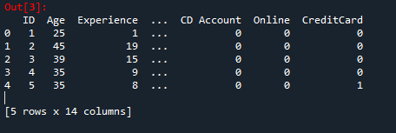

**dataset.isna().sum()**

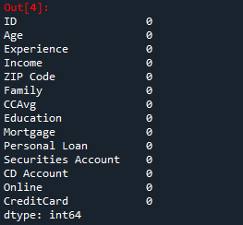

//Dropping columns

**d1=dataset.drop('ID',axis=1)**

**dataset1=d1.drop('ZIP Code',axis=1)**

dataset1.columns

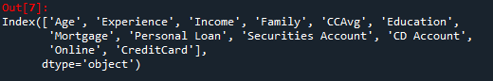

**Y=dataset1['Personal Loan']**

**X=dataset1[['Age', 'Experience', 'Income', 'Family', 'CCAvg', 'Education','Mortgage', 'Securities Account', 'CD Account','Online', 'CreditCard']]**

**import statsmodels.api as sm**

**X1=sm.add_constant(X)**

**Logistic=sm.Logit(Y,X1)**

**result=Logistic.fit()**

Optimization terminated successfully.

Current function value: 0.128435

Iterations 9

**result.summary()**

Out[14]:

<class 'statsmodels.iolib.summary.Summary'>

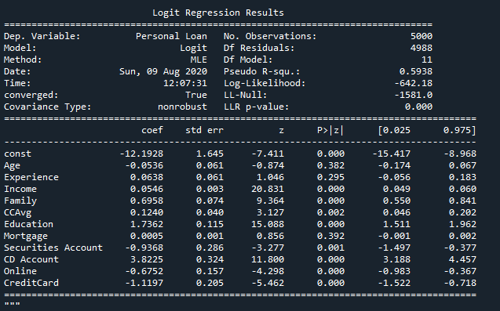

**Inferences:**

**Before giving personal loan following factors are significantly important.**

1. What is the annual income?
2. Number of family members.
3. Does customer posses any credit card?
4. What is average spending of credit card for month?
5. Does customer has securities account with bank?
6. Does customer uses internet banking facilities?
7. Education of the customer i.e. 1: Undergrad; 2: Graduate; 3: Advanced/Professional.
8. Does the customer have CD account with the bank?